County Planning Website- Tools for Residents
- Go to this County GIS Cannabis map to search for cannabis projects in your area:
https://sbcopad.maps.arcgis.com/apps/webappviewer/index.html?id=f287d128ab684ba4a87f1b9cff438f91 A map will appear, and as detailed in the screenshot below, click on the “layers” list at the upper right corner and check all of the boxes for different types of permits or licenses. Then zoom to the area you are interested in. Click on the site and the name and address of the project will appear. Go to step 2 below.

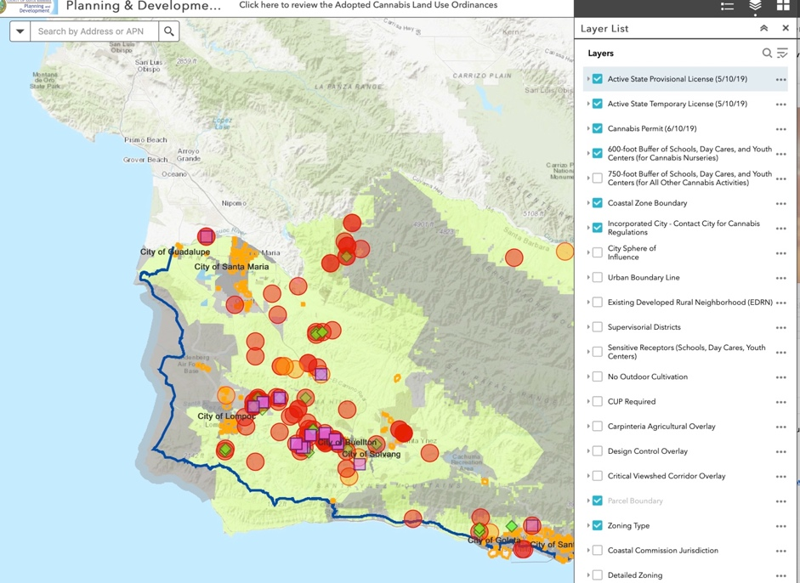

- Once you find the address and/or name of the project, Look up a permit application at this link
https://aca.sbcountyplanning.org/CitizenAccess/
This page will appear. Enter whatever information you have- exact address, or name of project.

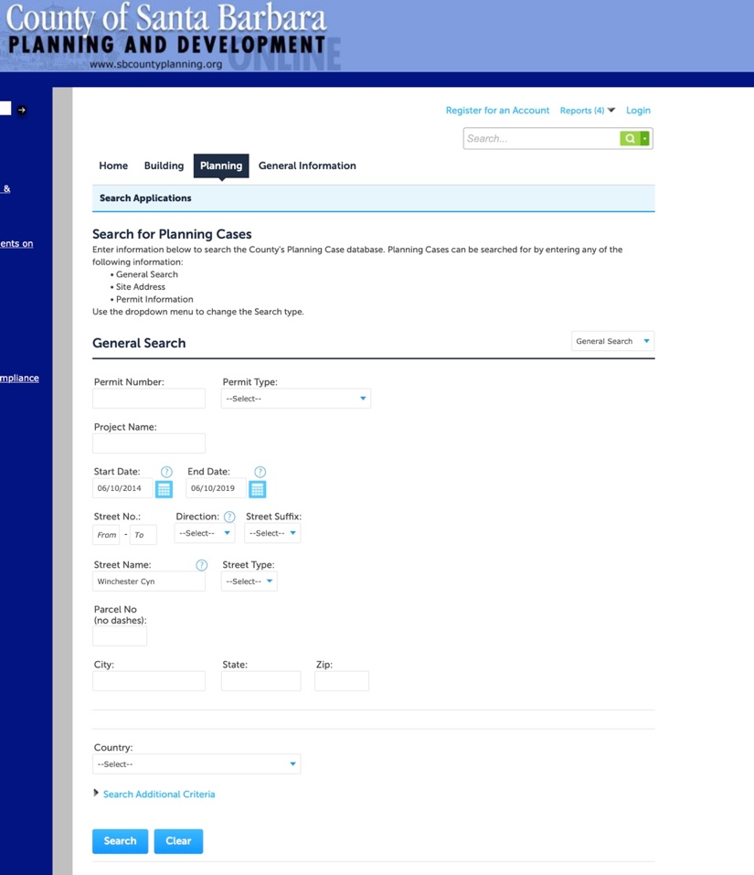

Additional information including phone numbers and email addresses for County Planning, and Licensing, and State Cannabis Regulatory agencies:

http://cannabis.countyofsb.org/contacts.sbc

Planning and Development:
- Planning permits and zoning information: pad-cannabis@countyofsb.org
- 805-568-2057

Business Licensing, Taxation and General Information:
- cannabisinfo@countyofsb.org
- 805 568-2777

Complaints:

File a complaint
- Always call 9-1-1 for life threatening emergencies!

State Cannabis Regulatory Agencies
- Bureau of Cannabis Control
- CalCannabis Cultivation Licensing
- Office of Manufactured Cannabis Safety

Get notifications when new information is released.
Receive email alerts when new information becomes available from the County regarding its cannabis permitting and licensing process. Use the button at the right to subscribe. You can also send us an email with comments.
Sign up

